Silver
- Plunderer
- Member

- 347 posts
- Gender:Male
- Location:Virginia Beach, Virginia
- Interests:Maritime history
Posted March 6, 2012 · Report post
i'm looking for a copy of a 17-18th century seaman's sign-on or shipping agreement, has someone come across one?

Daniel
- Pyrate Captain
- Member

- 652 posts
- Gender:Male
- Location:McLean, VA
- Interests:History, pirates, fiction, writing, writing historical fiction about pirates, jokes, games, law.
Posted March 9, 2012 · Report post
I've been looking for that for years. Never found one yet.
There's a specimen of a merchant ship's articles from an British 1835 statute, intended to be used as a model. I don't know if any ship ever actually sailed under these articles unmodified. Note that the OCR may have caused several misspellings.
Quote
An Agreement made, pursuant to the Directions of an Act of Parliament
passed in the Sixth Year of the Reign of His Majesty King William tlie
Fourth, between the Master of the Ship
of the Port of and of the Burthen of Tons,
and the several Persons whose Names are subscribed hereto.
It is agreed by and on the Part of the said Persons, and they severally hereby
engage, to serve on board the said Ship in the several Capacities against their
respective Names expressed, on a Voyage from the Port of
to \here the intended Voyage is to be described as nearly as can be
donCj and the Places at which it is intended the Ship shall touchy or if that cannot
be dione^ the Nature of the Voyage in which she is to be emphyedi] and back to the
Port of and the said Crew further engage to conduct themselves
in an orderly, faithful, honest, careful, and sober Manner, and to be at all Times
diligent in diieir respective Duties and Stations, and to be obedient to the lawful
Commands of the Master in every thing relating to the said Ship, and the
Materials, Stores, and Cargo thereof, whether on board such Ship, in Boats, or
on Shore [here may be inserted any other Clauses which the Parties may think
proper to be introduced into the Agreement ^ provided that the same be not contrary
to or inconsistent with the Provisions and Spirit of this Act]. In consideration of
which Services, to be duly, honestly, carefully, and faithfully performed, the said
Master doth hereby promise and agree to pay to the said Crew, by way of Com-
pensation or Wages, the Amount against their Names respectively expressed.
In witness whereof the said Parties have hereto subscribed their Names on the
Days against their respective Signatures mentioned.
Place and Time of Entry.
Men-i
Amount
ofW.g«
per Calendar
■^ Month,
Share, or
Voyage.
Wimmto
Name of Ship
in which
the Seamen
lutut>ed.
Note. — Any Embezzlement or wilful or negligent Loss or Destruction of any Part of
the Ship's Cargo or Stores may be made good to the Owner out of the Wages (so far as
thej will extend) of the Seaman guilty of the same; and if any Seaman shall enter
himself as qualified for a Duty to which he shall prove to be not competent, he will be
subject to u Reduction of, the Rate of Wages hereby agreed for in proporUon to his
lncompetency.

Silver
- Plunderer
- Member

- 347 posts
- Gender:Male
- Location:Virginia Beach, Virginia
- Interests:Maritime history
Posted March 9, 2012 · Report post
thank you for that post. it does follow what i have been coming across. i was able to find more info once i started using the word agreement instead of articals. in 1835 the english started to kept track of their seamen and masters got the task of doing the goverment paper work. i did learn the most seaman signed on with an alias in case they decided to jump ship, so the alias is not only a pirate triat. there are some agreements that list a man's rations also lost of pay for infractions. i found an agreement from st. kitts & nevis international ship registry titled "articals of agreement (crew agreement) between the master and seafarers serving onboard a vessel registered in st. kitt & nevis. it is dated 2002, a look at what seamen sign today. i'm still looking for that 1700's copy. if i can't find it i have dug up almost enough bits and peices to paste a acturate artical together. thanks again.

Fox
- Old Twillian
- Moderator

- 2,564 posts
- Gender:Male
- Location:Beautiful lush Devon, England
- Interests:Nautical history of the 16-18th centuries and living history based thereon.
Shooting pirates.
Posted March 9, 2012 · Report post
I can do you a 1694 privateering crew contract if that's any use?

Mission
- Goat Specialist
- Admin

- 5,082 posts
- Gender:Male
- Location:Monroe, MI
- Interests:Scholarly piracy, designing and creating haunted house rooms and props, movies, abstract thinking, abstruse thinking, obstructive thinking, ideating, random thinking, movies, cartoons, movies, movies scores, cycling, world peace and small furry dogs, movies, writing, drawing, personal skills training, gremlins and, of course, lest I forget, movies.
Posted March 9, 2012 · Report post
Weren't the privateering articles for Woodes Rogers' voyage spelled out in his book? that would get you to 1708.

Fox
- Old Twillian
- Moderator

- 2,564 posts
- Gender:Male
- Location:Beautiful lush Devon, England
- Interests:Nautical history of the 16-18th centuries and living history based thereon.
Shooting pirates.
Posted March 9, 2012 · Report post
The ship's articles are listed in Rogers' book (the re-written set, that is, not the original set), but not the individual contracts.

Capt. Sterling
- Sticky Fingers Sterling Needs a New Hat
- Member

- 10,302 posts
- Gender:Pyrate Hunter
- Location:here
- Interests:Killing pirates, haven't met one yet worth keeping alive....
Posted March 9, 2012 · Report post
On 3/9/2012 at 5:39 PM, Foxe said:
I can do you a 1694 privateering crew contract if that's any use?
YES! PLEASE!

Swashbuckler 1700
- Dread Pyrate
- Member

- 1,115 posts
- Gender:Male
- Location:Europe
- Interests:pyrates, pryvateers, naval military and other history, different books, good movies, music (a little bit), drawing, games,...
Posted March 10, 2012 (edited) · Report post
On 3/9/2012 at 5:39 PM, Foxe said:
I can do you a 1694 privateering crew contract if that's any use?
Is there signatures in it? if there is how many names and how many marks? So we can know someting about that how many man could write their own name.....
Edited March 10, 2012 by Swashbuckler 1700

Fox
- Old Twillian
- Moderator

- 2,564 posts
- Gender:Male
- Location:Beautiful lush Devon, England
- Interests:Nautical history of the 16-18th centuries and living history based thereon.
Shooting pirates.
Posted March 10, 2012 · Report post
In the case of the document above, it's an individual contract so it's got the signature of the person signing on, the owner of the expedition, and one or two witnesses.
There is a set of pirate articles in JF. Jameson's Privateering and Piracy which has a mix of signatures and marks, and both Marcus Rediker's Between the Devil and the Deep Blue Sea, and Peter Earle's Sailors have analyses based on the number of signatures and marks in the papers of the High Court of Admiralty. Roughly, it's about 2/3 of sailors and virtually every officer. However, as noted elsewhere, all that shows us is how many people could sign their name, nothing more.

Fox
- Old Twillian
- Moderator

- 2,564 posts
- Gender:Male
- Location:Beautiful lush Devon, England
- Interests:Nautical history of the 16-18th centuries and living history based thereon.
Shooting pirates.
Posted March 10, 2012 · Report post
For some reason I can't find the original jpeg of this, but here's a 'blank' contract (by which I mean I've removed all the hand-written stuff) signed by each member of the Spanish Expedition of 1694.
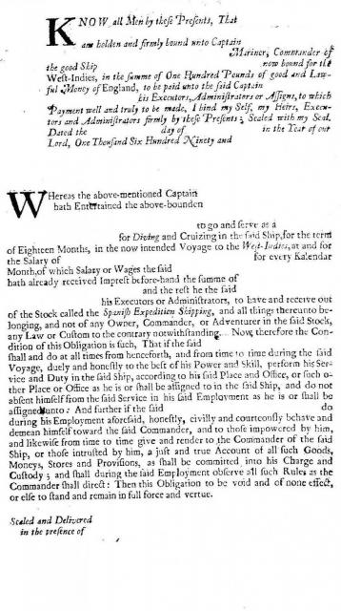

Silver
- Plunderer
- Member

- 347 posts
- Gender:Male
- Location:Virginia Beach, Virginia
- Interests:Maritime history
Posted March 10, 2012 · Report post
wow! was at jamestown today working on the ships. have had a round or two will get back. thank you

Capt. Sterling
- Sticky Fingers Sterling Needs a New Hat
- Member

- 10,302 posts
- Gender:Pyrate Hunter
- Location:here
- Interests:Killing pirates, haven't met one yet worth keeping alive....
Posted March 11, 2012 · Report post
Thank ye Foxe!!!

Silver
- Plunderer
- Member

- 347 posts
- Gender:Male
- Location:Virginia Beach, Virginia
- Interests:Maritime history
Posted March 12, 2012 · Report post
thanks foxe, i got the time to work through the 17th century legal talk and this is a great example of how i think one would read and look like. i plan on using lines from this. i noticed the bounded person was to pay L100 if he didn't complete the contract also there was the line concerning diving and cruizing in said ship. my question is, did the signer of the contract have a special skill as a wrecker (diver) and was this a salvage cruise for sunken spanish treasure? again thanks for the example.

Swashbuckler 1700
- Dread Pyrate
- Member

- 1,115 posts
- Gender:Male
- Location:Europe
- Interests:pyrates, pryvateers, naval military and other history, different books, good movies, music (a little bit), drawing, games,...
Posted March 12, 2012 · Report post
On 3/10/2012 at 4:42 PM, Foxe said:
For some reason I can't find the original jpeg of this, but here's a 'blank' contract (by which I mean I've removed all the hand-written stuff) signed by each member of the Spanish Expedition of 1694.
It would be good if you would have also the one with handwriting... but if it is not easy to find you can leave it be...

Fox
- Old Twillian
- Moderator

- 2,564 posts
- Gender:Male
- Location:Beautiful lush Devon, England
- Interests:Nautical history of the 16-18th centuries and living history based thereon.
Shooting pirates.
Posted March 12, 2012 · Report post
On 3/12/2012 at 11:50 AM, L. Silver said:
thanks foxe, i got the time to work through the 17th century legal talk and this is a great example of how i think one would read and look like. i plan on using lines from this. i noticed the bounded person was to pay L100 if he didn't complete the contract also there was the line concerning diving and cruizing in said ship. my question is, did the signer of the contract have a special skill as a wrecker (diver) and was this a salvage cruise for sunken spanish treasure? again thanks for the example.
This was the standard contract which everyone on the expedition had to sign, from Captain to cabin boy, and one of the objectives of the expedition was to dive Spanish treasure wrecks. The best known of the people who signed this particular contract was Henry Every... And it's thanks to Henry Every that this example of a contract has survived.
The cash bond was not an essential feature of such contracts, perhaps not even that common.

Fox
- Old Twillian
- Moderator

- 2,564 posts
- Gender:Male
- Location:Beautiful lush Devon, England
- Interests:Nautical history of the 16-18th centuries and living history based thereon.
Shooting pirates.
Posted April 2, 2012 · Report post
Found one with the handwriting in...
This is the contract of William May, one of only 5 of Every's men executed.
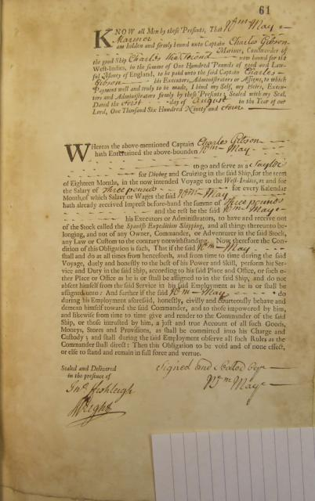

Swashbuckler 1700
- Dread Pyrate
- Member

- 1,115 posts
- Gender:Male
- Location:Europe
- Interests:pyrates, pryvateers, naval military and other history, different books, good movies, music (a little bit), drawing, games,...
Posted April 3, 2012 (edited) · Report post
On 4/2/2012 at 6:18 PM, Foxe said:
Found one with the handwriting in...
This is the contract of William May, one of only 5 of Every's men executed.
Glad to see that someone have (or had) as bad hand writing as I have ....
Speaking of old documents. It is blessing that many european nations used so clear writing style. But not all see what kind of font Swedes had in 17th century
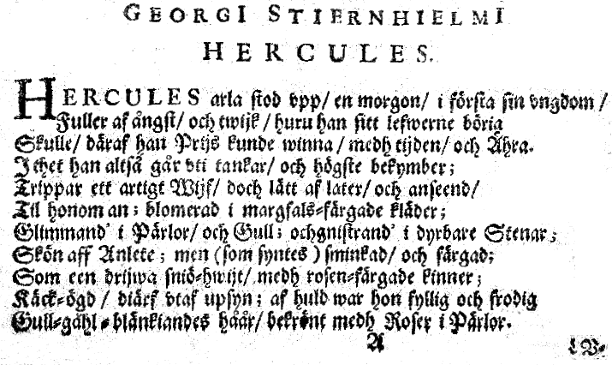
Edited April 4, 2012 by Swashbuckler 1700

